**O**rganic **C**hemistry **V**isualiser

Alvin Charles

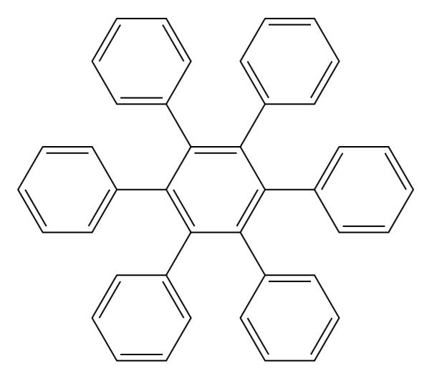

Contents

Introduction 3

Hardware specifications 3

Installation Guide 4

Main Screen 5

Menus 6

Functionality 7

Troubleshooting 7

# Introduction

OCV (Organic Chemistry Visualiser) is a utility used to parse and display common IUPAC nomenclature. IUPAC nomenclature is the standard used to describe organic names. Developed formally by IUPAC (International Union of Pure and Applied Chemistry), this nomenclature is detailed and extensive, covering many different types of compounds. OCV will not be able to parse all IUPAC nomenclature – professional IUPAC parsing and visualisation systems cost thousands of dollars apiece! – it aims to be able to parse most common nomenclature.

# Hardware specifications

The optimal computer configuration to run OCV through Visual Basic

* Windows 7 or above OS
* 1.6 GHz or faster processor
* 1 GB (32 Bit) or 2 GB (64 Bit) RAM
* 4 MB of available hard disk space
* DirectX 9 capable video card running at 1024 x 768 or higher-resolution display

# Installation Guide

To install OCV, extract the downloaded ZIP file into any directory (see *Figure 1*). The executable can be launched directly from this directory. The ‘resources’ folder that will appear after extracting the zip file must be kept in the same folder as the ‘OCV.exe’ executable for it to launch without error.

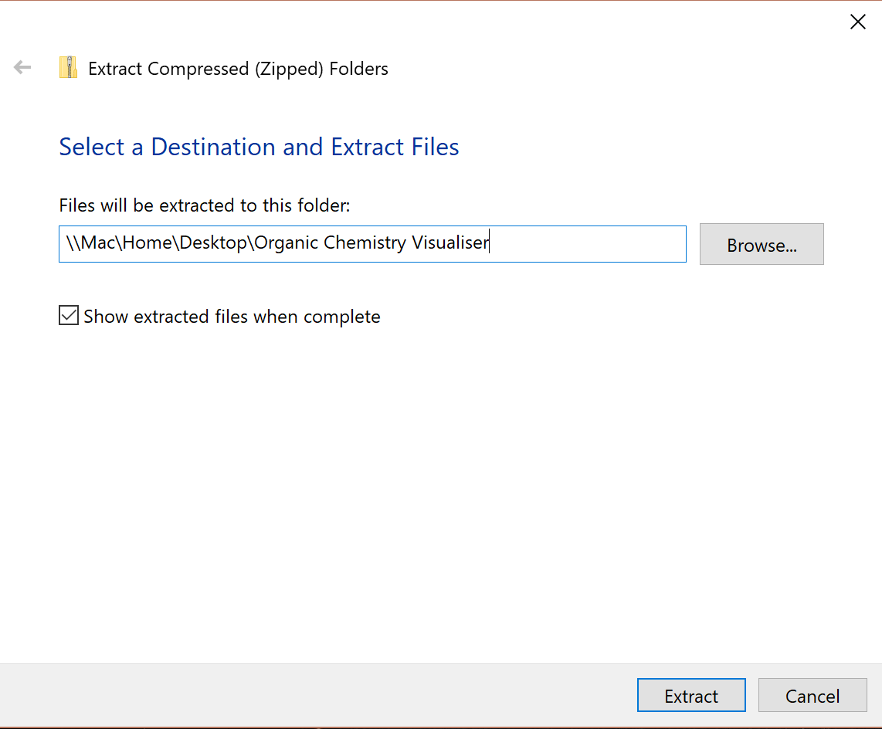

Figure 1 - extracting the compressed files

After extraction, the executable ‘OCV.exe’ can be run by being double clicked in File Explorer to use the program (see *Figure 2*).

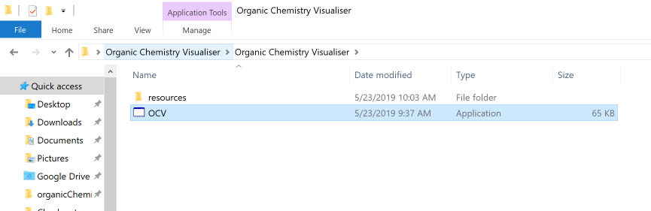

Figure 2 - the unzipped folder

# Main Screen

The main screen is the only screen of Organic Chemistry Visualiser. It has two sections – the textbox on the top side is where the user can enter the organic name to visualised. The blank canvas on the bottom of the screen is where the entered name will be visualised. See *Figure 3* for the screen on startup and *Figure 4* for the main screen with an example compound drawn.

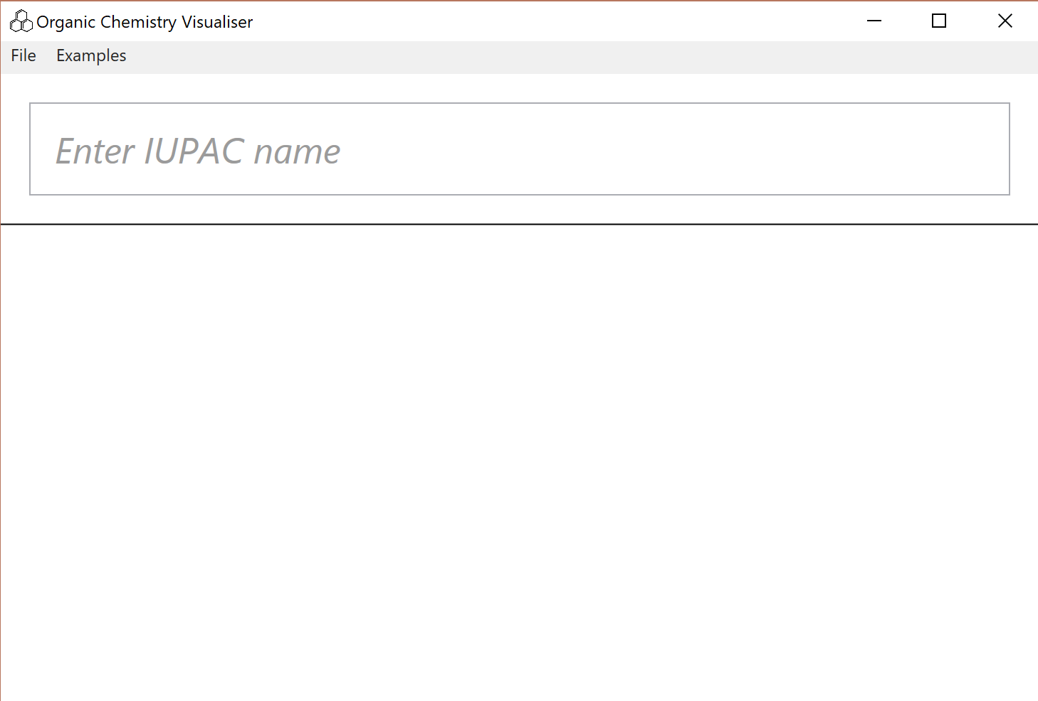

Figure 3 - main screen on startup

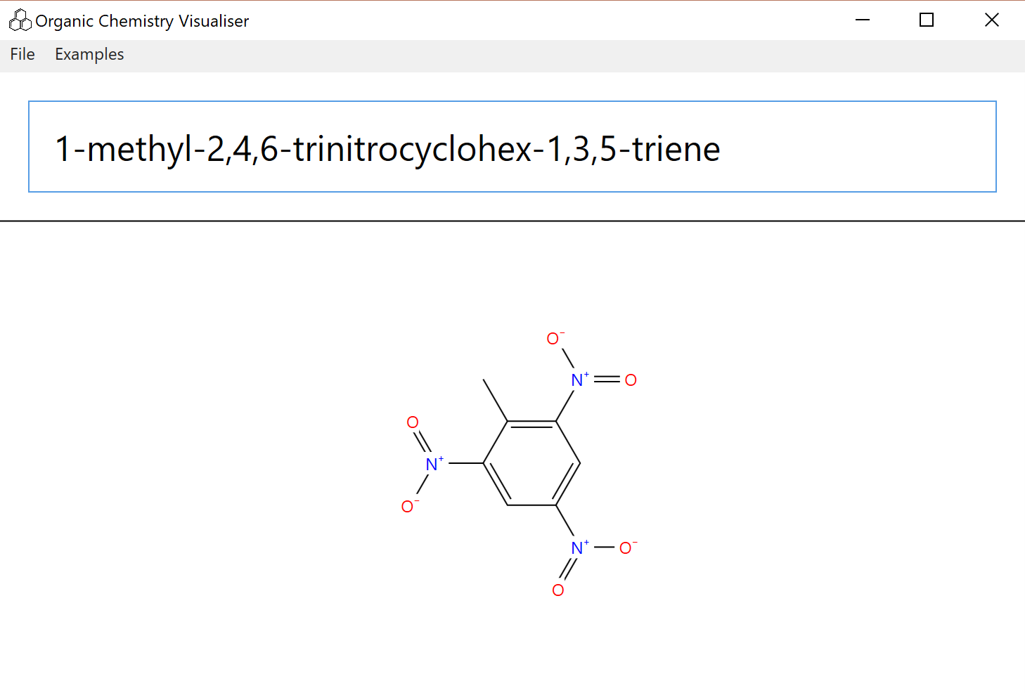

Figure 4 - main screen with TNT drawn

## Menus

There are two sets of menus available.

The file menu (see *Figure 5*) has 4 actions available –

* **Save:** saves the current compound into a file in a location of the user’s choice. The file’s extension is “.ocv” and its format is a plain text file containing an organic name in the first line.
* **Load:** loads a compound from a “.ocv” file of the user’s choice.
* **Export:** exports the currently drawn compound as a PNG or JPG image file in a location of the user’s choice.
* **Exit:** closes the window exits the application.

The examples menu (see *Figure 6*) contains a list of example organic compounds that can be loaded and drawn.

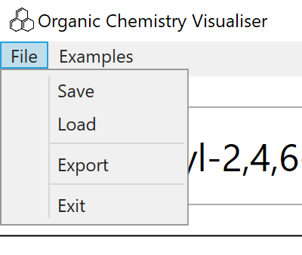

Figure 5 - the file menu

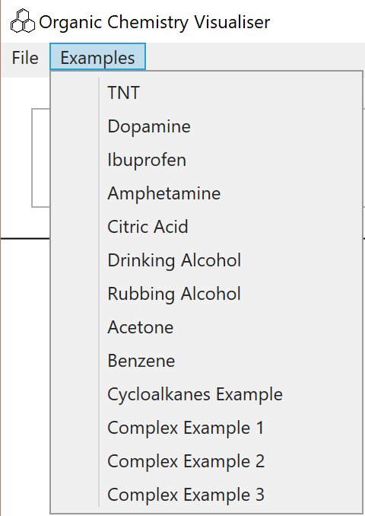

Figure 6 - the examples menu

# Functionality

OCV supports:

* Straight chain and cyclical main bases
* The following functional groups (through suffixes added to the main chain and/or substituents added to the front of name (whichever applies), e.g. “2-oic acid” = “2-carboxy”)
  + Alkenes and Alkynes
  + Acetyl groups
  + Fluoro, Chloro, Bromo and Iodo groups
  + Amide groups
  + Carboxylic acid
  + Aldehydes
  + Ketones
  + Alcohols
  + Amines
  + Nitro groups
* Recursive substituents (substituents with substituents)

OCV does not support:

* Naming with locants outside a main chain – e.g. 1-hexene is not supported, but hex-1-ene can be used instead
* Guessing locants. All locants must always be specified
* Nitrogen locants (e.g. N-methyl) not supported
* Any functional groups not present in the supported substituents list

# Troubleshooting

|  |  |
| --- | --- |
| **Problem** | **Resolution** |
| OCV does not start | Ensure that the OCV executable is extracted from the containing ZIP file before running. |
| OCV exits immediately on startup | Ensure that the ‘resources’ folder is present in the same directory as the OCV executable. (It is present in containing ZIP file.) |
| OCV freezes on name input | When a name is entered, a series of events takes place to parse and display it. On complex compounds, this process can be slow and take time. While this processing is happening, the application will be unresponsive until the name is drawn. |